Experiment-5

Aim
To analyze the histogram of an input image based on its color levels using Python and OpenCV.

Procedure
- Import the OpenCV and Matplotlib libraries.
- Read the input image using cv2.imread().
- Define the color channels: Blue, Green, and Red.
- Calculate the histogram for each color channel using cv2.calcHist().
- Plot the histograms using Matplotlib.
- Display the original image and its color histograms.

Code
import cv2import matplotlib.pyplot as plt
img = cv2.imread("image.jpg")colors = ('b', 'g', 'r')
plt.figure(figsize=(10, 5))
for i, color in enumerate(colors):
hist = cv2.calcHist([img], [i], None, [256], [0, 256])
plt.plot(hist, color=color)
plt.title("Color Histogram")plt.xlabel("Pixel Intensity")plt.ylabel("Number of Pixels")plt.xlim([0, 256])plt.show()
cv2.imshow("Original Image", img)cv2.waitKey(0)cv2.destroyAllWindows()

Sample Input
An image named image.jpg.

Sample Output
A color histogram displaying the intensity levels of the Blue, Green, and Red channels from 0 to 255.
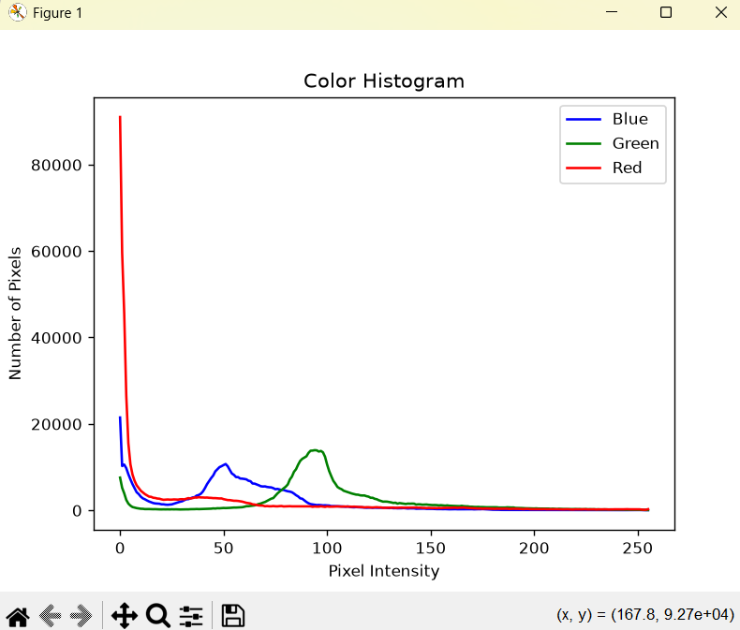

Result
Thus, the color histogram of the input image was successfully analyzed using Python and OpenCV.

